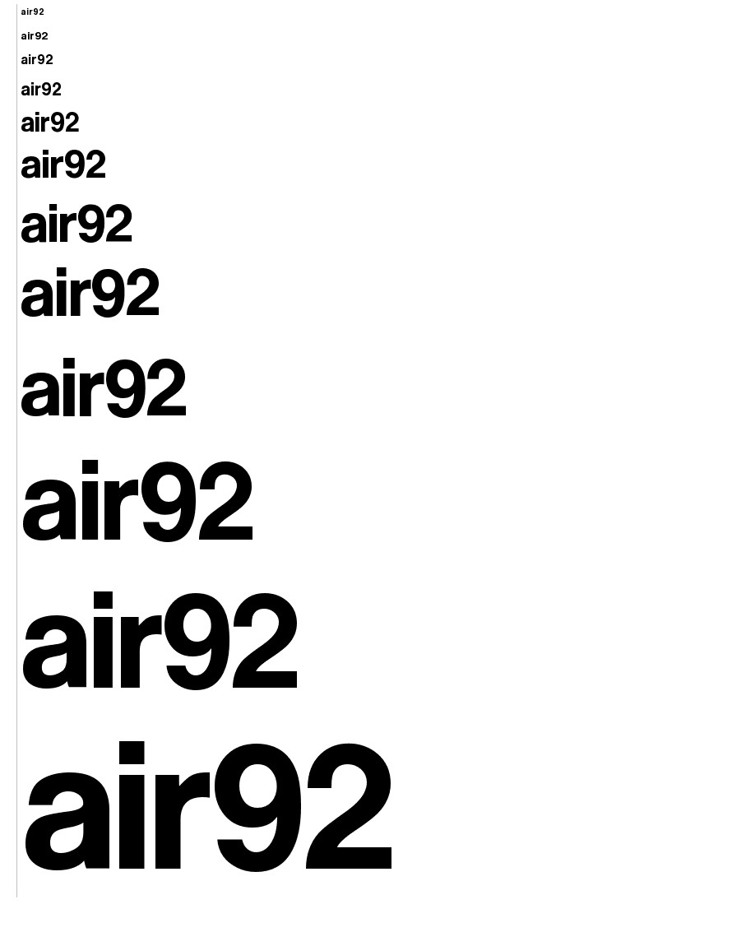

Investigations Report

Abd-Assamad Achouri, Yusof Bandar, Naim Ahmed, Faran Azadi, Evans Mensah Adeenu, Hamza Asif

Contents

Can users retrieve data directly from web server 3

How to send data from Raspberry Pi to an Android app 4

Wired Connection 4

Advantage 4

Disadvantages 4

Wireless Connection 4

Wifi Connection 4

Advantage 5

Disadvantages 5

Bluetooth Connection 5

Advantage 5

Disadvantages 5

Conclusion 5

How data will be sent from phone to web server 6

Wireless Connection 6

Advantage 6

Disadvantages 6

Mobile Data Connection 6

Advantage 6

Disadvantages 6

Can the Raspberry Pi be controlled offline 7

Investigation on Website features. 7

Design 7

Features 7

Security 8

Mobile ready version 8

Investigating the factors that affect air pollution 8

Temperature 8

Wind 8

Rain 8

Time of year 8

Investigating the main gases that contribute to air pollution 9

Carbon Dioxide 9

Sulphur Dioxide 9

Nitrogen Oxides 9

Chlorofluorocarbons 9

C0 9

Connection Overview Diagram 10

# Overview

This report contains information about how the user will interact with our system. For each interaction an investigation was performed explaining how the user will interact with the system and the advantages and disadvantages of each method. The report all explores how pollution levels can be effect and the effects of pollution.

# Can users retrieve data directly from web server

Users will be allowed to retrieve data directly from the web-server using an Application programming interface (API). The data allowed to retrieve will be raw pollution data for specific locations and any analytical results we have performed. Users will initially have to sign up to use the API either via website or Android app, giving them a unique key. Forcing users to sign up and obtain a unique key is usual requirement for any API, ensuring secure access to our web server.

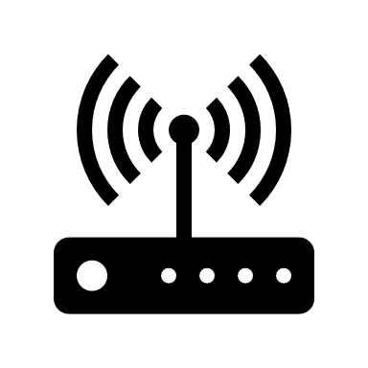

**Users**

**Web Server**

**API**

Allowing users to connect to our web server to collect data via API, allows the public to share data easily and efficiently without having to access a website or a app, specific users could also post data to our web server, permitting different sensors to post data. Documentation will also be written on how to post and access specific data to and from the web server.

# How to send data from Raspberry Pi to an Android app

The 3 main ways of sending data over to something is usually via a wired connection (ethernet, USB), a wireless connection (WIFI) or the conventional Bluetooth. I will see the benefits and drawbacks of each of these 3 methods.

## Wired Connection

This is usually seen as mainly using an ethernet connection however as it’s from a phone and a Raspberry Pi this wired connection would usually be in the form of a USB cable like many phones use Micro USB to USB cables to connect a phone to other devices. In our case the Pi would have a USB to be able to attach to make a connection between the phone and the Pi. You could also have a Flash drive to connect to either the phone or Pi transfer the data to the flash drive then move it to the other medium.

### Advantage

* More secure as data can’t be intercepted especially using a USB to Micro USB cable
* Speeds are usually faster over a wired connection than wireless
* Drag and drop files or easy to move without too many processes to go through

### Disadvantages

* Both phone and Pi must be in same location as each other can’t be done remotely
* Can’t be used by multiple users who may have phone but not near the Pi
* Can’t send data to other places maybe another phone or Pi

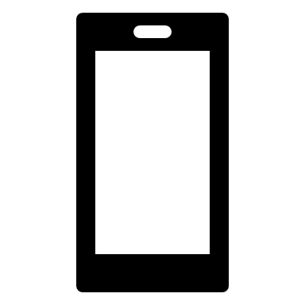

**Phone**

**Sensor**

**Wired Connection USB – Micro USB**

## Wireless Connection

## Wifi Connection

This method is mainly using WIFI where you still need to be connected to the internet for both devices but can send files without having to be in the same place as each other. This is basically connecting to devices without the use of wires like a wired connection.

### Advantage

* Main advantage over other is don’t have to be in same location as the device
* Don’t have to carry around a wire such as a USB to need to send data over
* Can have more than one person sending data as not bound by amount of ports available to you.

### Disadvantages

* Isn’t as secure as wired connection so data could be intercepted by someone else
* BOTH devices NEED to be connected to the internet first to send the data
* Connection can be obstructed by things such as thick walls or everyday household items

## Bluetooth Connection

Bluetooth is a similar method to a wireless connection as it doesn’t require wires however data is usually exchangeable over short distances, using a special radio frequency to transmit data, it creates a short-range network.

### Advantage

* No need to use wires like wireless connection.
* Very secure as connection only between you and the device connected to.
* Can have more than one device connected and up to around 8 devices can be connected on a single connection.

### Disadvantages

* Even though wireless still have been be around the device around 100m so more than usual wired connection.
* Bluetooth isn’t very battery efficient even latest version can still drain a lot of battery.
* Can’t send many big files and can also be very slow sending medium/large files.



**Phone**

**Sensor**

**Wireless connection either via WIFI or Bluetooth**



## Conclusion

Overall, I do believe using a wireless connection be it Bluetooth or WIFI is better to use to send data from the Raspberry Pi to the Android app than using a wired connection (USB cable). Wireless connection allows you to be anywhere and can send data which is a big plus over a wired connection even if it’s less secure however, this can be overcome by encrypting the data before it is sent. I am still unsure on which wireless connection is better, Bluetooth or WIFI, as I yet to see how both would be used in this case and which would be practical though Bluetooth, though wireless you still must be near the device itself. This will have to be seen and tested soon to see which would be the most suitable for us to use.

# How data will be sent from phone to web server

The two mains ways which you can send data from a web server are through WIFI and through using your mobile data. This will explore both and the advantages and disadvantages of both as they are quite similar in many ways.

## Wireless Connection

Where you are using WIFI you will need to make sure that you are connected to the internet to be able to send the data to a web server.

### Advantage

* You can send the data from anywhere with WIFI if you have a stable internet connection which you are connected to.
* Usually a cheaper option to sending data than a mobile connection.
* Can have more than one person sending data as not bound by amount of ports available to you.

### Disadvantages

* Isn’t as secure as someone on the same WIFI connection can intercept the data.
* Need to be connected to the internet first to be able to send the data to the server otherwise you can’t.
* Connection can be obstructed by things such as thick walls or everyday household items.

## Mobile Data Connection

This method of using your phones mobile data to send data which will likely be affected by your sim tariff. With this method, you will likely be using a 3G or in some cases a 4G connection to send the data to the server. 3G is simply a type of mobile phone technology that allows you to make calls, texts and access the internet. 4G is better than 3G as it means more data can be transmitted faster.

### Advantage

* Usually more secure than conventional WIFI connection.
* Hassle free as you don’t have to mess around with wires, modems etc.
* Don’t have to mess around with setting anything up such as logging into a WIFI connection or entering passwords to gain access as its usually already set up for you with your sim.

### Disadvantages

* Can be unexpected cost with using just mobile data as you may think your just using it to send data to a server though in the background it could be downloading updates for your hundred apps that need to be updated.
* You usually have a limit and these can range to 500mb to 20GB depending on which you buy. Usually with phones you may be on pay as you go or have a monthly contract where you are allocated an amount of data you can use usually around 1GB-5GB
* Connection timeouts can usually occur more times than with using WIFI depending on the network you are with and the support the provide to accessing 3G and 4G connections. Sometimes may find yourself using 2G connection and sending data may take forever.



**Web Server**



**Phone**

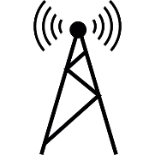

**Wireless connection either via WIFI or mobile network**

# Can the Raspberry Pi be controlled offline

In the event, the users phone loses power or the connection goes down, the sensor could not be controlled. Allowing the raspberry pi to have physical control over the sensor could solve any issues the phone might have.

Soldering on physical buttons and low power screen will allow user to have control over the sensor without having a phone. The physical buttons will allow simple control, turning the sensor off and on, turning the low power screen off and on, turning off and on any LED indicators. The screen could display simple status data.

The main advantages of online control is allowing the user quick offline control over the sensor, the main disadvantage is it increases the overall power consumption of the Raspberry Pi and relies on a GPS module being installed.

# Investigation on Website features.

The website will have mostly the same design and implementation choices as the Mobile app. The major difference being that the App has direct control over the Raspberry Pi while the website can only view and sort the collected information.

## Design

* Just enough information on the home screen to not overwhelm the user. Tells the user exactly what the website does.
* Navigation should be easy to understand. The website should use clear headings and subheadings on the navigation bar.
* Have an “About Us” and Contact page with all the relevant information.
* The website should display good quality image or videos. These could be about the Raspberry Pi or something related to pollution.

## Features

* The website should provide the user with the option to register or login.
* The user can view and sort the collected data in a number of ways.
* All the data should be retrieved from an online database i.e. MySQL.
* The Website should analyse the data and predict future pollution trends. Produce weekly graphs.
* The website should remember user preferences.

## Security

* The user is only allowed to view the data.
* Only a user with admin level access can edit data values.
* The website will be hosted locally.

## Mobile ready version

* The website layout will adopt to the screen on which it’s being browsed.
* Mobile users will be requested to install the app.

# Which features will the Android app have?

In regards of the features of our app, we want to specify the app’s policy or what it should do:

* Android’s connection to the Raspberry Pi;
* Retrieve data from database;
* Allows user to analyse results;

## Mechanism of our app through its features:

### Retrieve data from database;

To retrieve data from the database to the Android app, it is recommended to use **SQLite** (for our database) and a web server (**using node.js**).

The database will allow us to store and retrieve details of the user and the information in regards of the pollution measurement statics through a WIFI connection.

## The reasons behind using SQLite for this app are:

* It enables the android databases created in Android to be visible to the application that created them;
* Content is updated continuously and automatically so that there is no work lost in the event of a power failure or crush;
* Content stored in an SQLite database is more likely to be recoverable decades in the future, long after all traces of the original application have been lost. Data lives longer than code.

## Android’s app connection to the Raspberry Pi

We use **node.js** to connect to our web server due to its effective, fast and reliable performance. Here’s the most important question;

### How do we make the connection?

* Firstly, the connection between our android append our raspberry is through wireless connection built in both devices.

### Connections between server, database and user

* The android app makes a request to a server (node.js script), which handles communication, opens a connection and receives the string which can then be processed into an object.
* In the node.js server, we’ll open an **sql** connection to our SQL database and run sql query.
* Finally, the query will iterate through the database response and encode it into the string (we created) which is sent back to the android app which can then process it.

### Allows user to analyse results;

This feature is enabled by:

* Retrieving data from database
* Measured pollution data is retrieved by a sensor built in our raspberry Pi device and sends it back to our app.
* This data is finally analysed on our mobile app through graph.

# Investigating the factors that affect air pollution

To ensure that we maintain the consistency in accuracy when measuring air pollution we need to take under consideration factors that may distort our data.

Temperature

Temperature is directly proportional to the rate of reaction that occurs within the air. The greater the temperature the more air pollution such as, photochemical, with be formed with respect to time.

Wind

Wind pressure determines the diffusion rate of gases and molecules. The greater the air speed the less air pollution with be contained within a certain volume - less air pollution detected.

Rain

Rain can clean the air from air pollutants such as, sulphates and soot.

Time of year

During the summer the Sun is out much for much longer compared to winter, as a result photochemical smog has more time to form. Humans are out for longer and they use fossil fuel powered substances more compared to the winter.

In the winter the air pollution which reacted with sunlight is less but there is a high concentration of other pollutants such as carbon dioxide.

Some other factors that affect air pollutions are pressure and humidity

# Investigating the main gases that contribute to air pollution

Main gases contribute to air pollution, listed below are some of the pollutants and their effects. Making sure we collect data about these pollutants is necessary to get a accurate overview of pollution in the area

Carbon Dioxide

C02 is a gas that traps heat within the atmosphere via the greenhouse effect. This effect melts ice which increase the sea levels

## Sulphur Dioxide

S02 is a gas that when combined with water and air produces acid rain, which can distort marble and limestone buildings.

## Nitrogen Oxides

The reaction of N02 with air, sunlight and other substances produces Photochemical smog, which also creates global dimming. This can affect human’s respiratory system.

## Chlorofluorocarbons

Causes holes in the ozone layer. This exposes humans to the harmful rays of the sun, which can give us cancer.

## C0

Carbon monoxide reduces amount of oxygen human organs receive.

# Connection Overview Diagram



**External Users**

**Web Server**



**Phone**

**Sensor**

**Wired Connection USB – Micro USB**



**Wireless connection either via WIFI or Bluetooth**

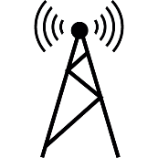

**Wireless connection either via WIFI or mobile network**